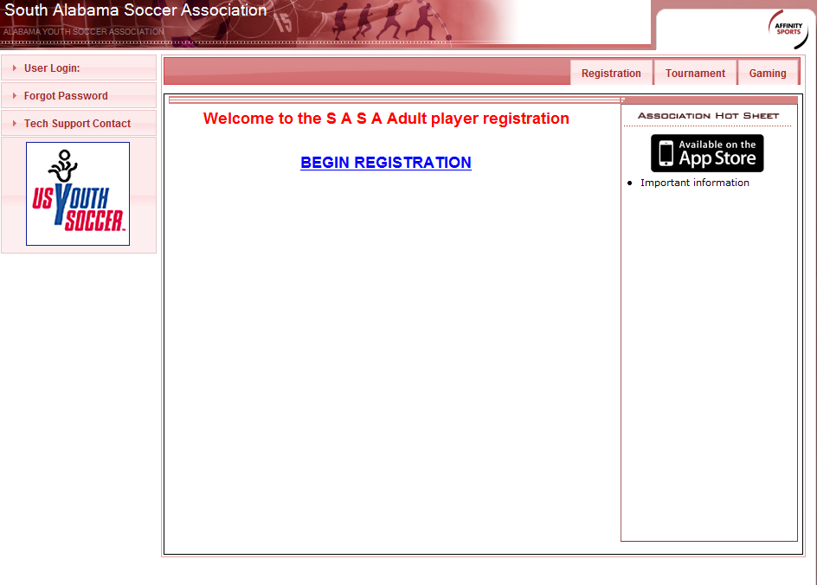
Click on Begin Registration
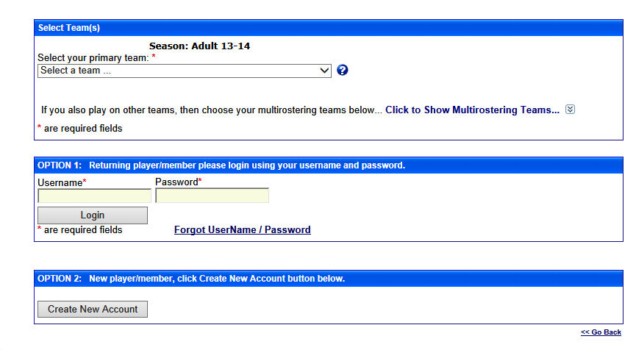
Select the Team name from the drop down menu then click Create New Account
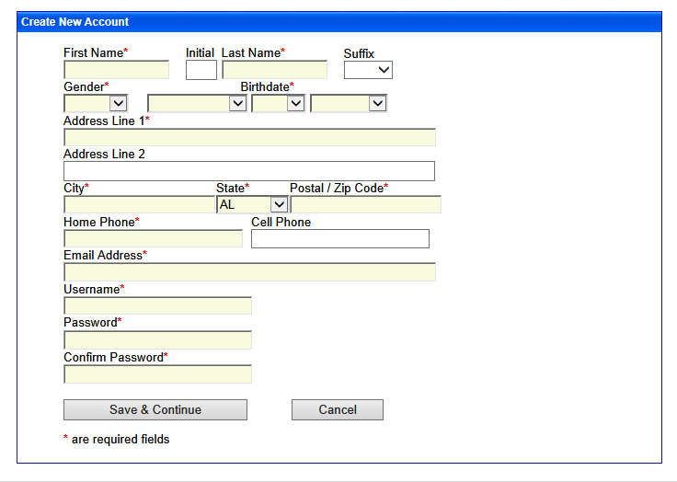
Enter info into all boxes with an * next to it as shown below, then click Save & Continue
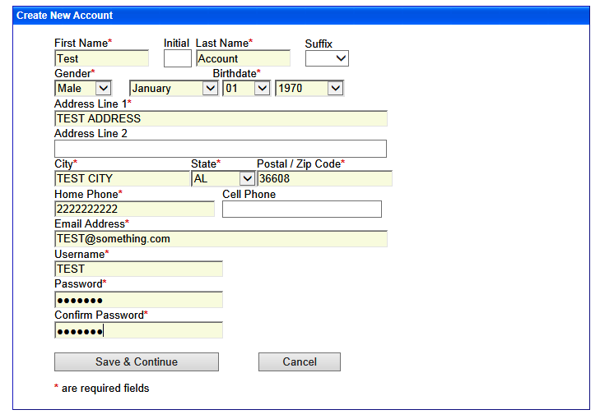

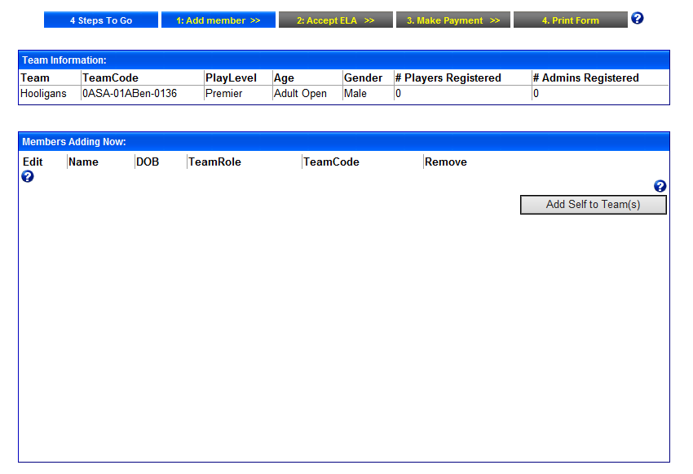
Click Add Self to Team

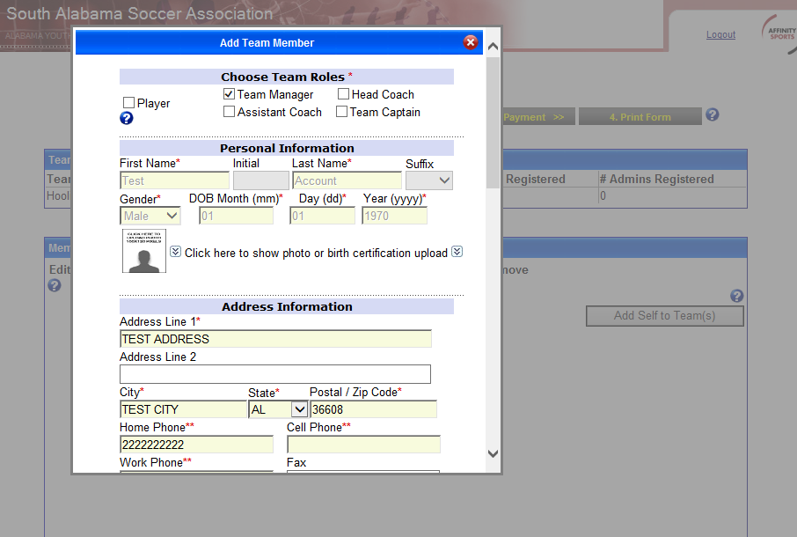
If you are a new player completing this process then select Player, enter all the info and skip down to page 8 of this document.
If you are the Team manager, then Select Team Manager at the top, then info in all required info,

Answer the questions (shown below),
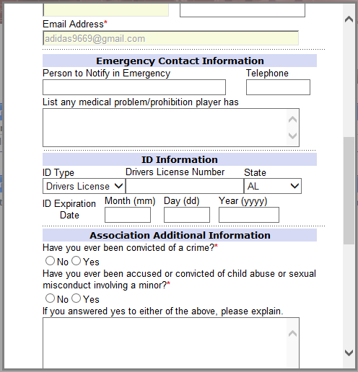
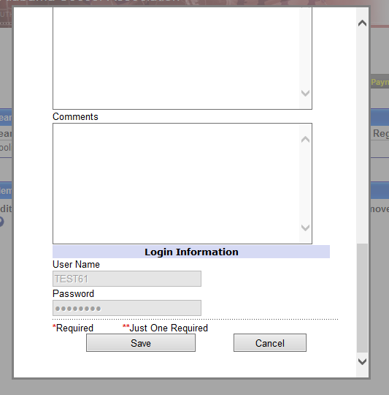
Click Save
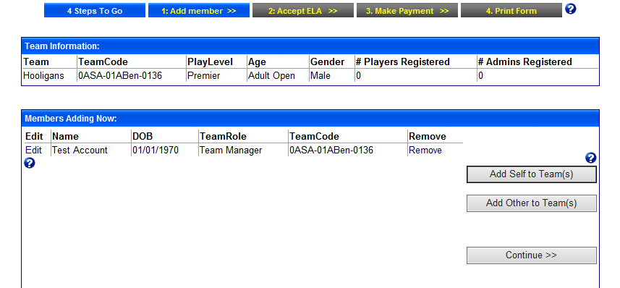
Click Add Other to Team
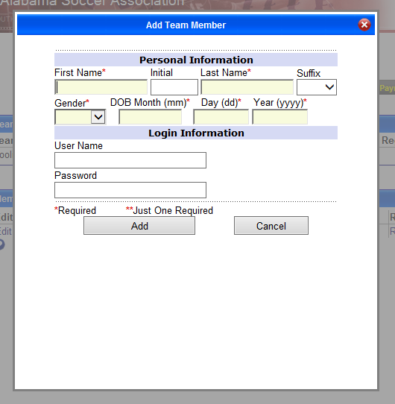
Enter player information here for new players that you are adding, you do not have to create a username for each person. Click Add
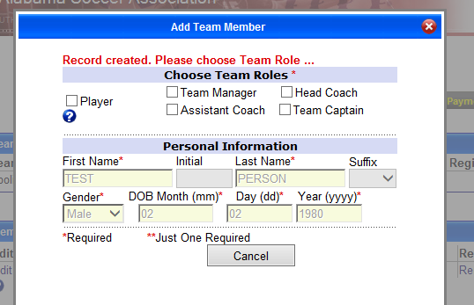
Place a check next to Player
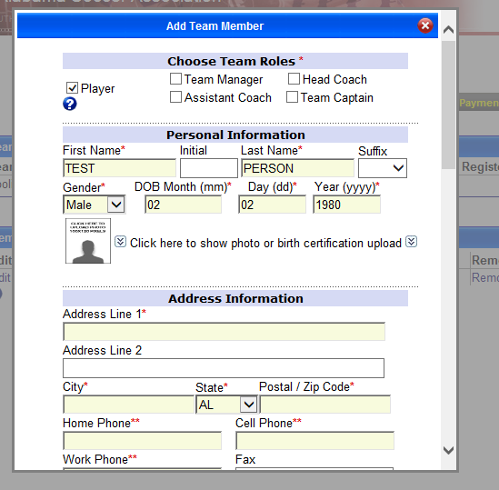
Enter all required information
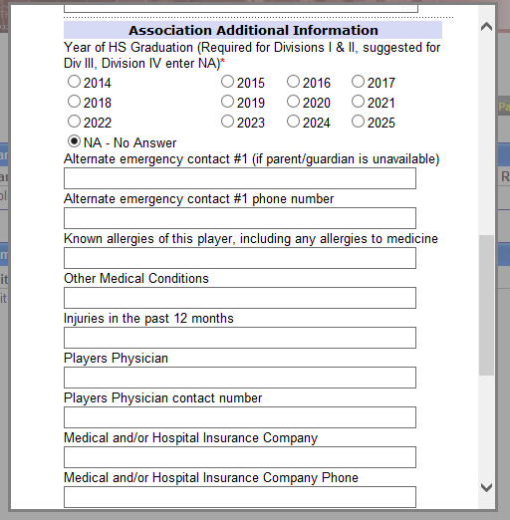
Answer NA-No Answer on the HS Graduation
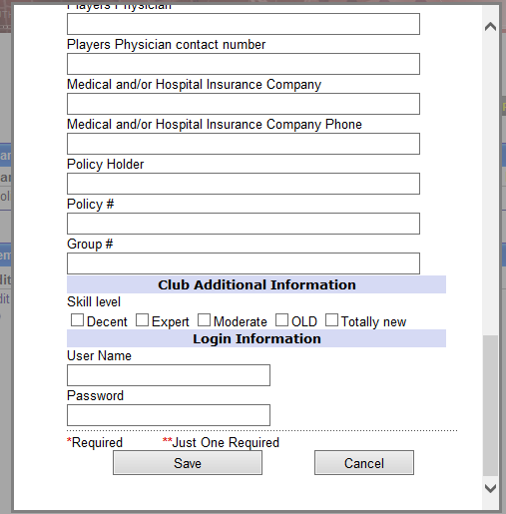
Continue to the bottom and Click Save
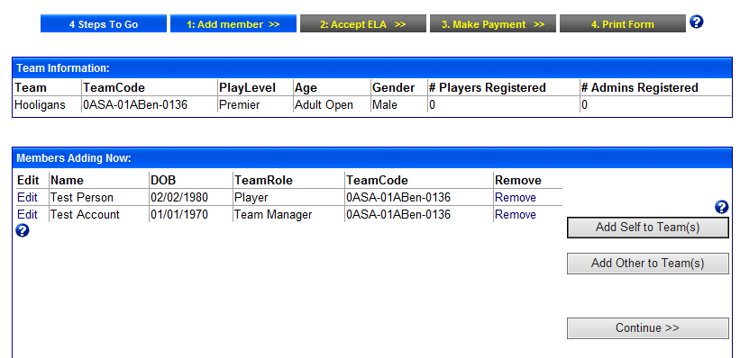
Verify that all players are added. Team Managers please make sure to click add self to team a second time if you’re also a player on your team. Once all players are added, click Continue.
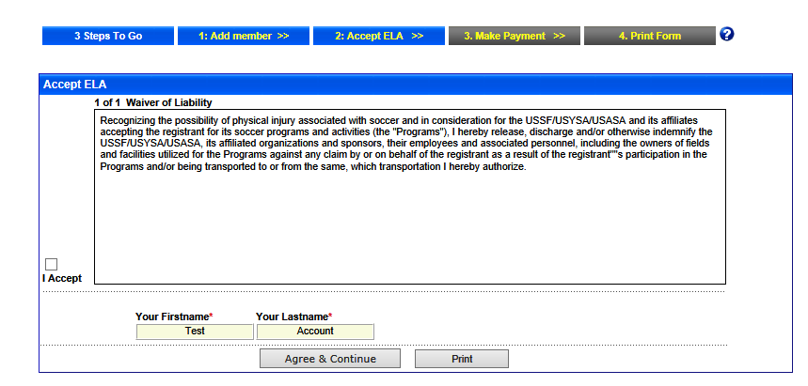
Click I Accept, and then click Agree & Continue. If you are registering more than one person (i.e. Team Managers) then it will ask you if you are accepting the agreement for all players. Once you click Agree& Continue then it will navigate you to the payment screen. The current amount for registration is $25 per player. If you see something different than this please notify the League President. Also, Please make sure you put in a valid email address for each player so that you will get you receipt for payment and registration. Once all players have been registered and paid for thru the site, please notify the League Registrar that you need a player card printed unless the player has an old card they are using.
If you have any questions, please reach out to the League President or Registrar.

